Division(s): N/A

ITEM PF6E

PENSION FUND COMMITTEE – 21 FEBRUARY 2008

OVERVIEW AND OUTLOOK FOR INVESTMENT MARKETS

Report by the Independent Financial Adviser

- The extent and ramifications of not just the ‘sub-prime’ mortgage debacle in the USA, but of the general under pricing of risk globally are gradually becoming apparent, but what is still not clear is the extent of its impact on economic growth. Consensus estimates of growth have still only been trimmed back slightly as the following figures show.

Consensus Forecasts Of GDP growth % | 2007 | 2008 | 2009
UK | 3.1 | 1.9 | 2.5
USA | 2.2 | 2.1 | 2.8
EUROZONE | 2.6 | 1.9 | 2.0
JAPAN | 1.8 | 1.5 | 1.8

- Growth is clearly going to be weaker this year than the consensus, but a recession (being two quarters of negative growth) in the USA is not yet a certainty despite one or two investment banks having declared it started in December 2007. However, as the Federal Reserve chairman has said ‘the downside risks to growth have become more pronounced’. The Philadelphia Federal Reserve Banks’ business outlook survey of general business conditions has fallen to -20.9, its lowest reading since the 9/11 terrorist attacks in 2001. Sales of new houses in the USA have fallen to a 12 year low, while other housing indicators are at levels last seen in the housing crisis of 1990-1992. House prices are over valued in the US, UK and some European countries as the following charts show.

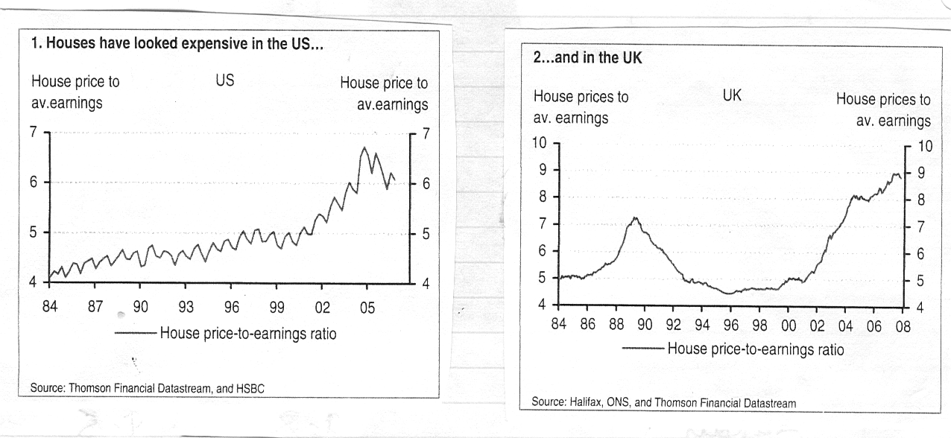
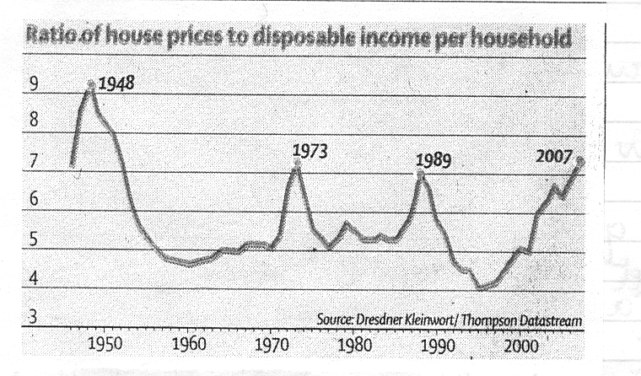

House prices are falling in the USA and weakening in the UK, Ireland and Spain. With the consumer over borrowed, not just on mortgages but on other debt this is impacting consumer confidence; retail sales volumes actually fell in December in the UK, when normally over Christmas they are very buoyant. While the labour market in the UK is so far holding up, in the USA it is stumbling with the lowest number of jobs added in December since August 2003. Although activity is steady in the Euro zone, business confidence in Germany, the zone’s largest economy has fallen to 103.0, the lowest level for two years and the Commission’s economic sentiment indicator is on a clear downward path reaching 104.7 in December, the lowest since March 2006. The slow down in Japan has been aggravated by the dramatic reduction in house building, following the clumsy introduction of new anti-earthquake regulations and overall economic growth will be nearer 1.3%.

- Going forward in the western economies, banks are tightening their lending requirements, resulting in a restriction in the volume of credit available, not just to lower quality borrowers, but even in the size of lines of credit to borrowers with stronger covenants. Moreover, borrowers will only benefit to a limited extent from the reduction in official interest rates, as banks (including mortgage lenders) will seek to widen margins and so rebuild reserves to offset losses on securitised lending (sub-prime, collateral debt obligations – CDO’s etc). However, company balance sheets are generally strong compared to a few years ago and banks’ tighter lending criteria should not impact them too much. Further, if the oil price were to continue in the $90-$100 range it would begin to be a drag on activity. However, very recently it has eased to $87 in spite of the need to rebuild industrial countries oil inventories from 51 days, the lowest since autumn 2004.

- Economic growth in the developing world, particularly the BRIC countries (Brazil, Russia, India and China) is expected to continue at a rapid rate. China has become concerned that the economy may be over-heating, with growth of over 11% and has been gradually increasing restraining measures. Nevertheless, the concept that developing countries’ economies can completely decouple from those of developed countries or that they can help support activity in developed countries is probably too optimistic.

- In spite of weakening economic activity, inflationary pressures remain strong, particularly through imported costs principally energy (oil and gas), soft commodities (wheat has risen sharply in price) and to a lesser extent hard commodities, particularly metals. Further, the price of low cost products from developing countries has been creeping up. So the dilemma for central banks continues. While they cannot control imported inflationary pressures, they wish to restrain the secondary effects through labour costs (wage and salary claims), but at the same time, depending on their remit, they need to support economic growth if weakening or at least not put further downward pressure on growth. The problem for the Bank of England is compounded by sterling weakening, which adds to inflationary pressures. Thus, while the US Federal has reduced official interest rates from 5.25% to the present 3.00% (most recently with dramatic reductions of 0.75% and 0.50%), and rates could be reduced much further, but probably not as low as 1% as in the 2002-03 recession, the Bank of England will probably move at a more sedate pace. It has already cut by 0.25% to 5.50% in December and it could reduce by a further 1.00% to 4.50% over this year. The European Central Bank is playing an even harder game, muttering about lifting rates, but will probably reduce by 0.50% to 3.50% during this year. Japan will hold rates at 0.5%. Once weakening growth/recessionary trends are stemmed, central banks may raise interest rates again rapidly to prevent another asset bubble developing.
- However, monetary policy needs to be supported by fiscal policy. The USA is proposing swift action to implement an emergency $150 billion fiscal stimulus package to help stave off a possible recession. The UK budgetary position is very tight and the scope for increased counter cyclical expenditure would seem to be minimal, while in the Euro zone there is no suggestion of such an initiative.

Markets

- The crisis in the markets in this cycle has not been caused by the general economic outlook, as is usual, even though economic imbalances were building up, but rather by fears that the architecture of the modern financial system is under threat and that a collapse in part would then impact the economic outlook. It began with the sub-prime loan problem in the USA, spread through the securitised loan market and in particular the CDO market (collateralised debt obligations which often included a portion of sub-prime), credit default swaps (CDS) whereby insurance can be bought against the default of loans (a $45,000 billion market) and now to the bond insurers themselves (if the bond insurers failed, bond prices would fall to reflect lower credit ratings). As a result of these cumulative fears, volatility in the stockmarket has risen from around 10 on the VIX index in the first half of last year to the current 29, having been as high as 37.

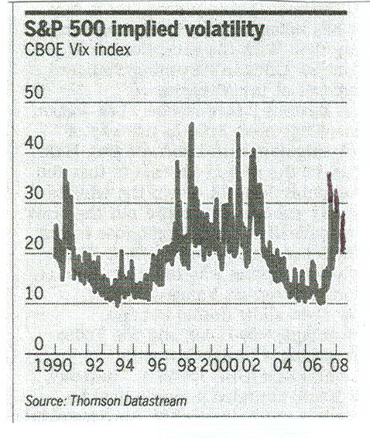

Within this volatility, risk is being more realistically priced back into financial assets, both bonds and equities. The spreads (the margin of yield of corporate and other issues carry over government debt) have risen sharply as the chart below shows.

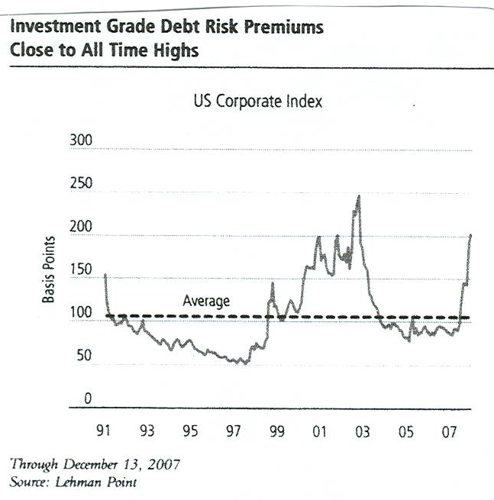

Government bond yields have fluctuated declining on fears of economic slow down recession together with the ‘flight to quality‘, or inflation, on interest rate reductions. UK gilt yields show this.

 | Nov 2006 | June 2007 | Aug 2007 | Nov 2007 | Jan  2008 | Current
UK gilts – 10 years  Benchmark | 4.7% | 5.5% | 5.0% | 4.6% | 4.4% | 4.6%

However, some aspects of the crunch in the markets have begun to ease. Money market interest rates, which for three month sterling were about 1 percentage point higher than official rates (6.7% v 5.75%), are now at only a very small margin (5.53% v 5.50%).

- The volatility in the equity markets reflects the ebb and flow of fears and optimism on the degree of economic slow down or of a recession that may result from the credit crunch. Within this volatility, risk is being repriced more realistically. Over recent months large capitalisation stocks (the FTSE 100 index as a proxy) have substantially out performed medium and smaller capitalisation stocks, so that the mid-caps price/earnings valuation premium which was substantial, has now almost disappeared. At current levels (FTSE 100) the market does not look expensive with a prospective 2008 price/earnings ratio of 12.4 times and an earnings yield of 9.4%, more than double the yield on the government 10 year benchmark gilt. The Euro zone market is also reasonably priced on a prospective 12.0 times, but the US market is somewhat more expensive at 19.0 times prospective against a 20 year average of 16.4 times. However, these valuations need to be set against profits being at a record cyclical high as a percentage of GDP in most western economies and, unless the entry of developing countries such as China and India into the global economy with their huge supplies of labour have moved profits on to higher level, converting profits on to a cyclically adjusted basis would lift valuations to a more expensive range.

- Technically the UK equity market plunged through the support at 5850 on the FTSE 100 index to 5578 on 21 January, but it has since bounced. The next area of technical support is around 5400. The market has fallen nearly 20% since its June and October 2007 highs and so may be classed as a bear market. The bottom of the bear trend has probably not been seen and it generally occurs when the market experiences ‘capitulation’. Then there could well be change of sector leadership, when those sectors that have experienced huge falls such as banks, property and builders move ahead and current leaders such as mining stocks, where base metal prices have already fallen sharply, cede their leadership. Probably slower growth, if not a mild recession in the USA, is already priced in the market and the market’s rise from the bottom could, as it normally is, be very sharp. Looking across the valley, there is already good value in certain areas.

- UK commercial property yields have moved up significantly over the last two months as the chart below shows.

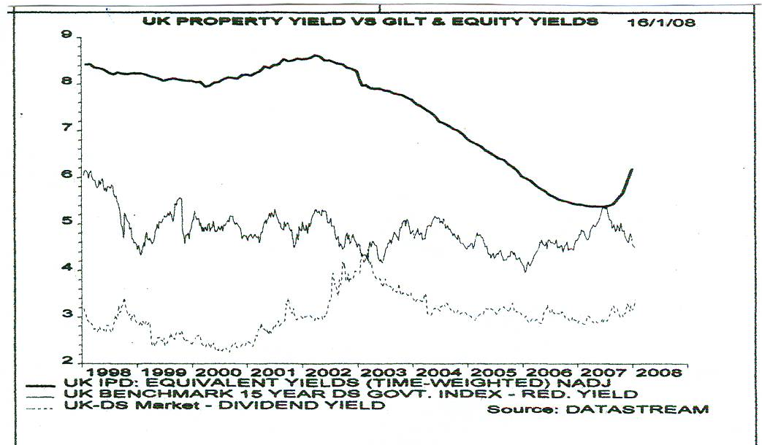

The speed of this turnaround from the yield compression experienced earlier last year has surprised the market. Rental growth remains firm and is strong in the central London markets, although rents outside London are rising at more modest rates. However, capital values fell by an average of at least 10% over the year as whole (values rose in the first half and fell sharply in the second), which also pushed yields up. As a result, the total return (capital and income) on property was about -5% in 2007, compared with around +18% in the three previous years. The total return in 2008 will at best be zero, if not negative, with income part of offsetting further falls in capital values. Property shares are now standing at huge discounts to underlying asset values.

- The main feature in the currency markets since the onset of the credit crunch has been the strengthening of the Japanese yen, which has hardened from Yen 120 to the US dollar to 107 as many involved in the ‘carry trade’ (borrowing yen at very low interest rates to invest in high yielding assets in other countries) have unwound their positions. With the recent sharp falls in sterling from US$2.10 to US$1.95 and against the euro from €1.48 to €1.32, this has magnified sterling’s decline against the yen from nearly yen 250 to yen 206. With UK interest rates likely to decline in coming months and with a huge current account balance of payments deficit, the prospects are for sterling to decline appreciably in the medium term. In contrast the US dollar could be over-sold and so stabilise.

A. F. BUSHELL

Independent Financial Adviser

February 2008

